Chocolate Peanut Butter Breakfast Smoothie

This is one of my favorite recipes! I used a base recipe from a blog I read a few years ago, I wish I could give credit to that blog! I tweaked it a little to make it a little tastier! It’s a fast smoothie that will keep you sustained throughout the morning and you can take it with you on your way to work!

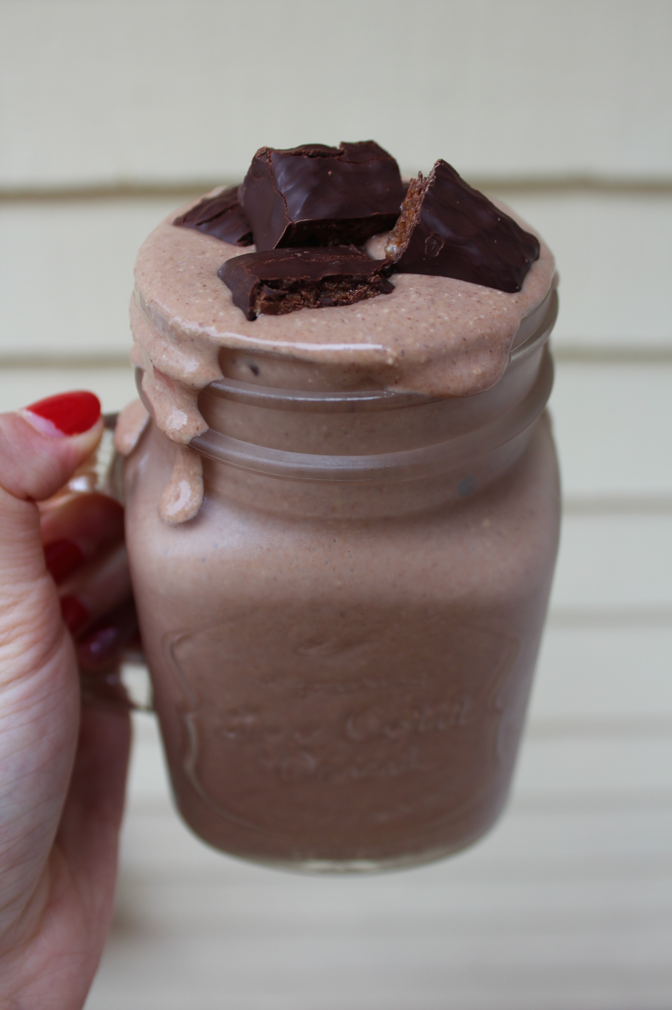

Recipe:

1 Frozen Banana (cut into smaller pieces before frozen)
1 Cup Almond Milk
½ Cup of Oats
1 heaping Tablespoon of Cacao Powder
1 heaping Tablespoon of Peanut Butter
1 teaspoon of Cinnamon

Optional:
1 Scoop of Chocolate Protein Powder
1 Tablespoon of ground flax

Blend all ingredients together in a blender.

** I’m a huge fan of texture and I like to have something to crunch on so I like to use chunky peanut butter, or add in cacao nibs. In the picture I skipped the protein power and chopped up a Chocolate Square Protein Bar to top my smoothie!

